Denbigh Administration

Denbigh Intro 2016

www.denbigh.com.au  Tel +61 2 4647 1375  Fax +61 2 4647 3410 | ABN 99 167 352 749  Macarthur Anglican School  Cobbitty Road  Cobbitty NSW 2570 | PO Box 3166  Narellan NSW 2567  Australia

Table of Contents

Getting Familiar with the Database 3
Toolbars 3
Buttons and Icons 4
Community File 4
Family File 4
Students Files - Future, Current and Former 4
Current Students - Related Files 5
Staff File 5
Working with Records 6
Moving from one file to another 6
Moving around Denbigh 6
Quick Search 6
Viewing records as forms or lists 8
View records as list 8
Finding Records - Quick Find 9
Finding Records 9
Mode Button 9
Perform Find 10
Performing an "And" Find 10
Performing an "Or" find 11
Find Result 12
Constraining the Found Set 12
Find Result 13
Extend the Found Set 13
Find Results 14
Omitting data in a Find 14
Find Results 15
Find using Operators 16
Find in any Field - Right mouse click 16
Using Shortcuts or function keys 17
Find Student (New Versions of Denbigh 2014) 17
Search Assistant 18
Saved and Recent Finds 18
Finding random records with Mark Function 19
Find Results 19
Sort Records 20
Paste without formatting 20
Export Records 21

Training Manual

Getting Familiar with the Database
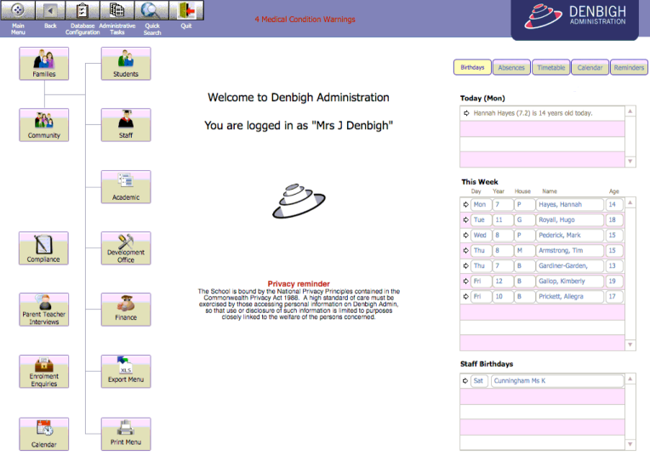
Main Menu

Toolbars
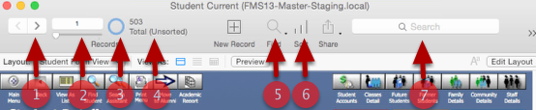
- Click to scroll record to record
- Record Number (can enter a number to go to a record)
- Pie Chart depicts approximately the portion of total records (click to see opposite of find)
- Records Found out of total number of records (after finished with a find)
- Find Records in any field
- Sort Records on any field
- Quick Find

Buttons and Icons
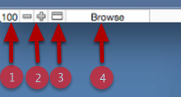
- Scale size of window
- Zoom out/in buttons
- Status Toolbar toggle
- Mode Menu (Browse, Find, Layout and Preview).

Community File
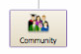
Denbigh is based around a community file, only 1 community record per person. A person may be a member of different files, Staff, Students Current, Former, Further and Parents.

Family File
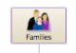
All families are attached to students Current, Former or Future.

Students Files - Future, Current and Former
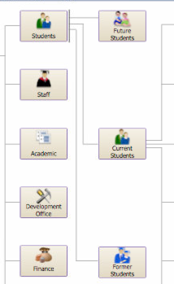
There should only be one student record Future, Current or Former.

Current Students - Related Files
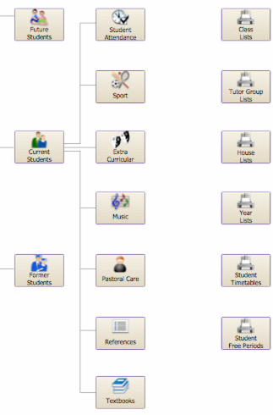
Student Attendance, Sport, Extra Curricular, Music, Pastoral Care, Reference and Textbooks are all files that relate to the current students.

Staff File
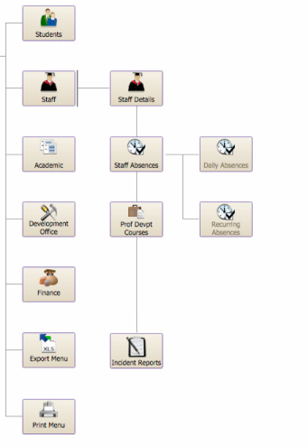
Staff absence, Professional Development, Daily Bulletin, Playground Duty are all files that relate to the Staff File.

Working with Records
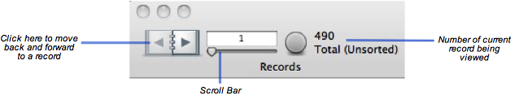
Click the pages of the teledex button to view each record, or drag the scroll bar.

Moving from one file to another
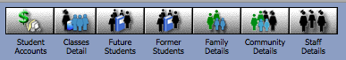
Click to go to a file.

Moving around Denbigh
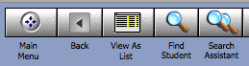
Click the Main menu button at any time to back to the Main menu. The Back button will take you back to the previous layout that you were on. View as list displays records in a list view. Find Student will to into Find for searching. Search Assistant will display options for quick searches (e.g. finding all primary or secondary students).

Quick Search
Click the Quick Search button to search any person in the database.
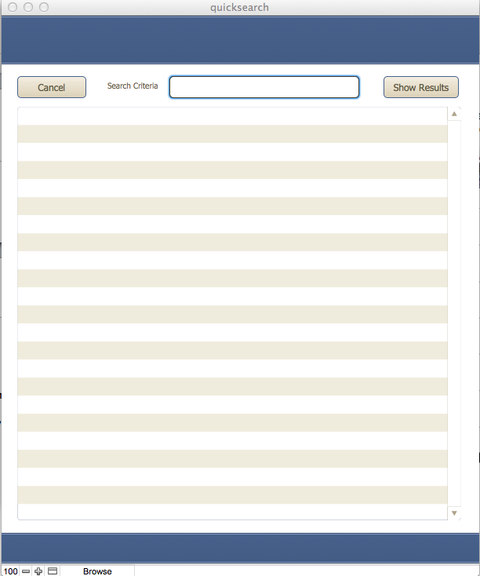
Enter the search criteria and press the tab, enter keys or click the "Show Results" button.
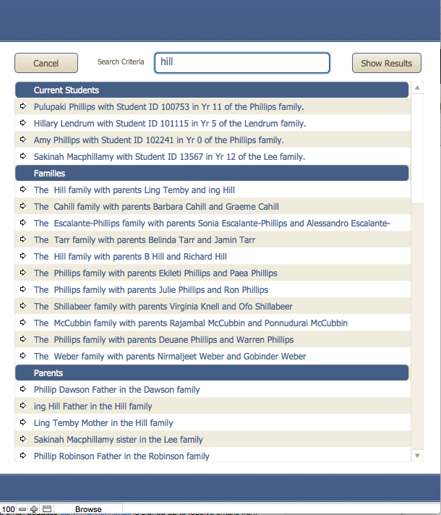
List of either matching data will display, grouped in type of person. Click on the arrow to go to that person's record.

Viewing records as forms or lists
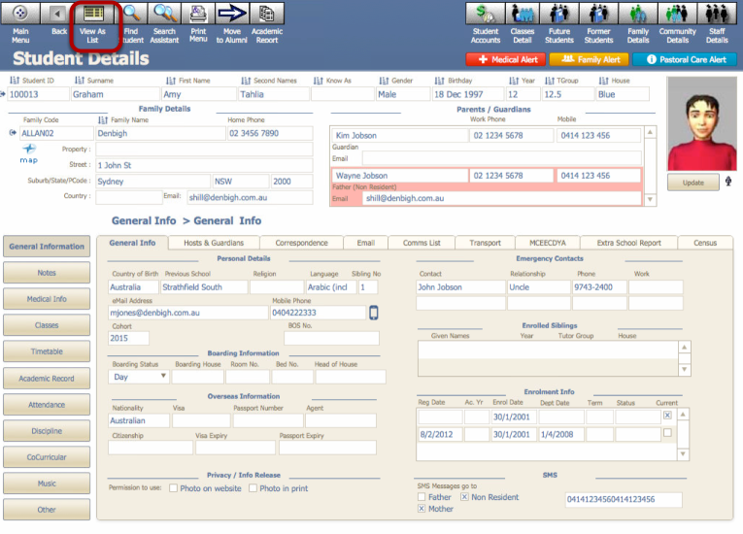
Click the View as List button to view the current records in list view

View records as list
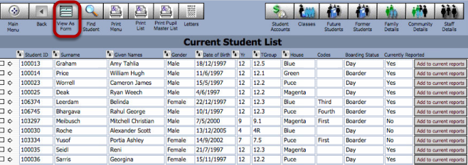
Click to view records in form view

Finding Records - Quick Find
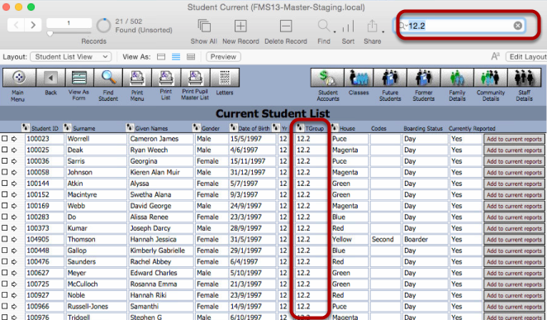
Using the Quick Find feature you are able to search across any field on a layout without needing to enter Find mode or specify the value in more than one field. This will depend on which fields have been set for this feature and in which layout. This example show finding tutor group 12.2.

Finding Records
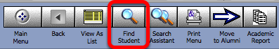
Click on the Find Student button to Find or use the keyboard short cut Command (Windows) or ⌘ (Mac) F. All fields appear blank so that you can search on any fields or multiple fields.

Mode Button
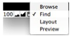
Or Change the Mode button to find. All fields appear blank so that you can search on any fields or multiple fields.

Perform Find
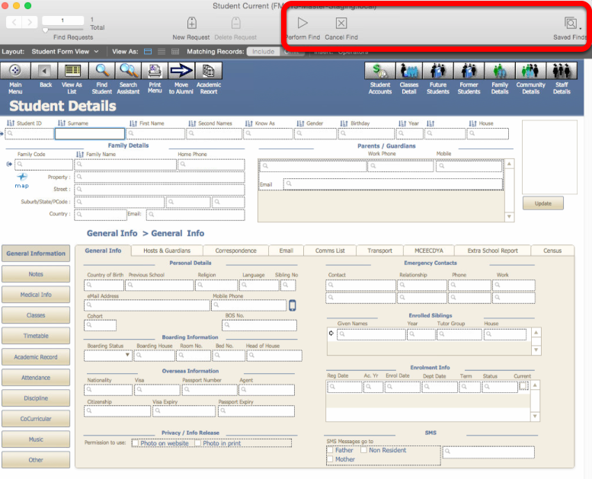
Click the “Perform Find” or the Enter key to perform the find. To cancel the find click the “Cancel Find” or to view previous finds, click on the Saved Finds button.

Performing an "And" Find
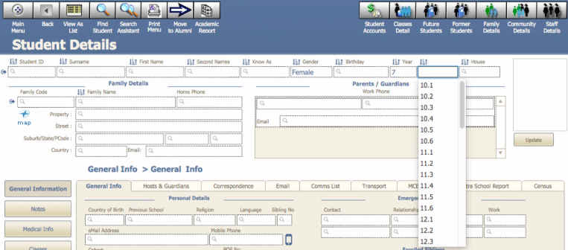
Enter data in multiple fields. In this example it will find all females in year 7.

Performing an "Or" find
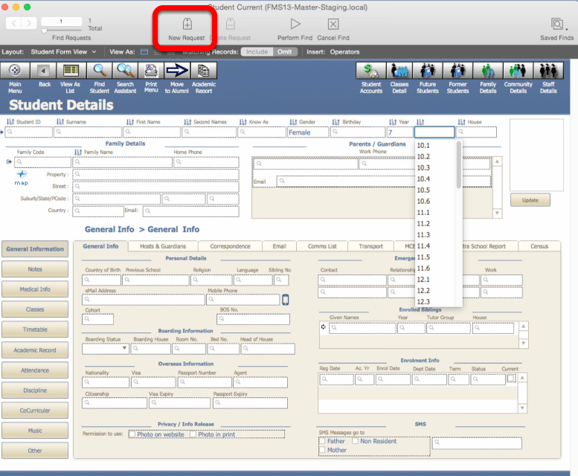
Click find enter the details of the first criteria to search, then Click "New Request".
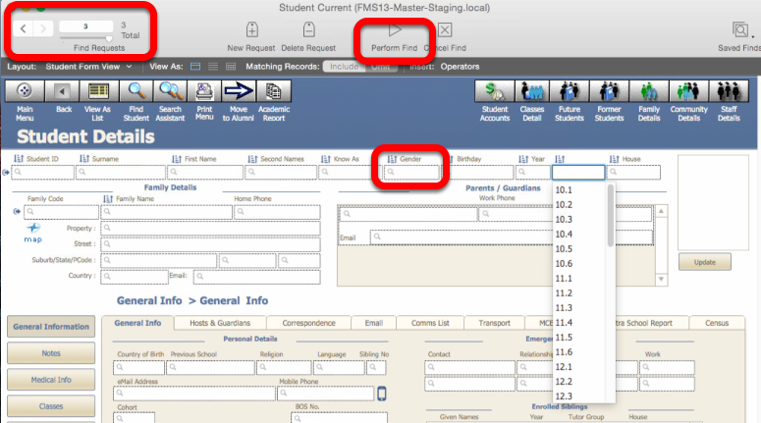
Enter the second Criteria, and then click Perform Find.

Find Result
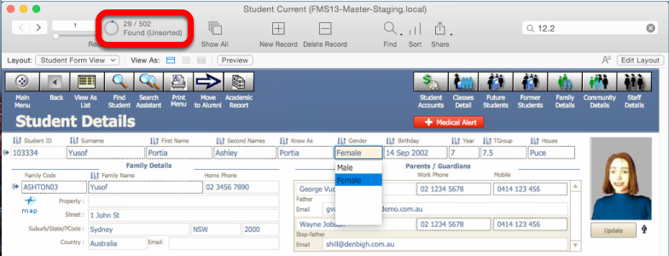
This will find all females and all year 7 students.

Constraining the Found Set
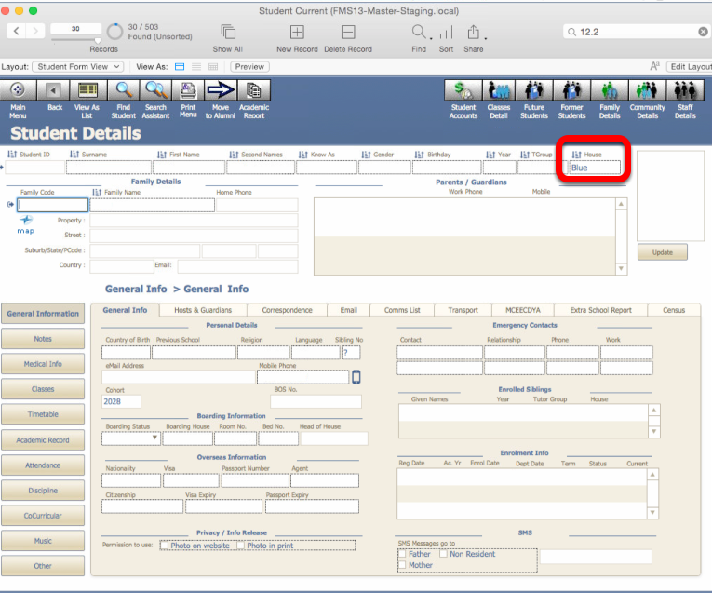
Click find enter the details to constrain the found set to, in this example we had found all females and year 7 students. We are now going to just find those in this found set that are in the Blue House.

Find Result
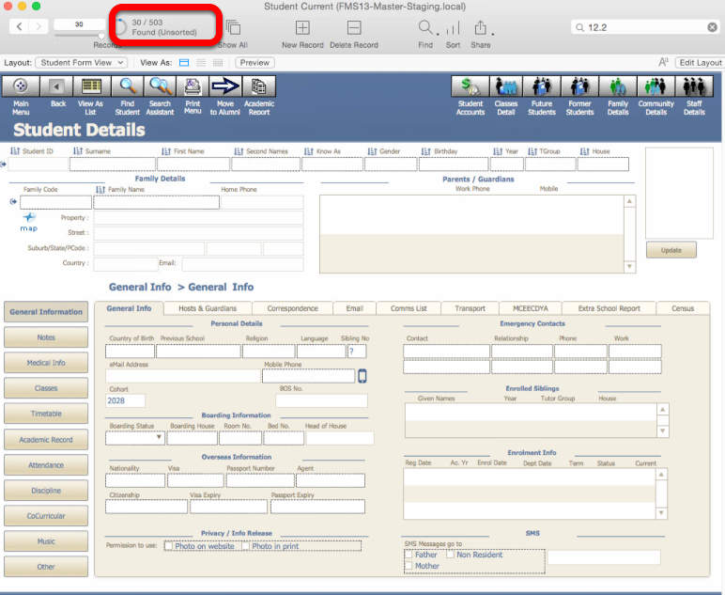
This has now found within the previous find, only students in the Blue house.

Extend the Found Set
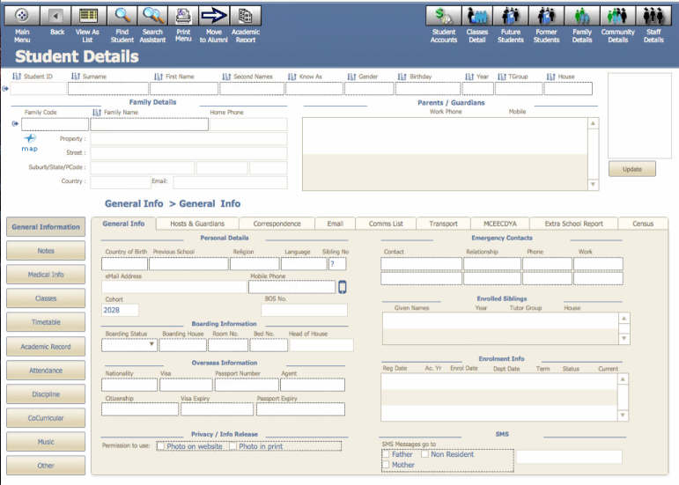
Click Find and enter the criteria. Add year 7 in the academic field.

Find Results
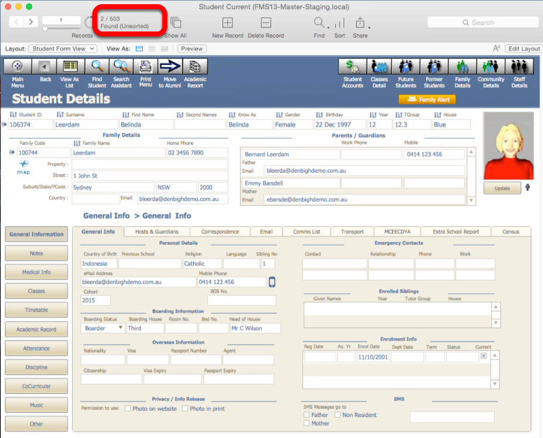
Added all students in year 7 to the previous find.

Omitting data in a Find
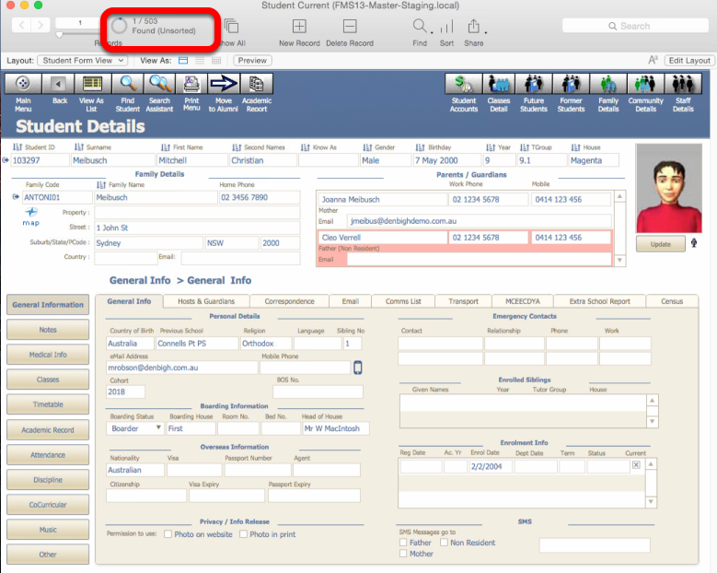
In this example we have found all students in year 9, but need to exclude all students that are in 9.2 Roll Class. First perform a find of year 9 students. Click Find enter 9 in the Year field, then Click to Perform Find.
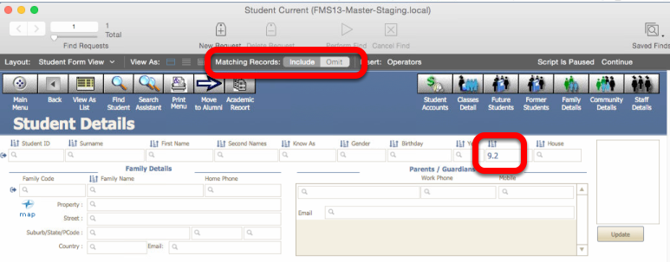
Click the Find button. Enter 9.2 in the tutor group field and then click the "Omit" button.

Find Results
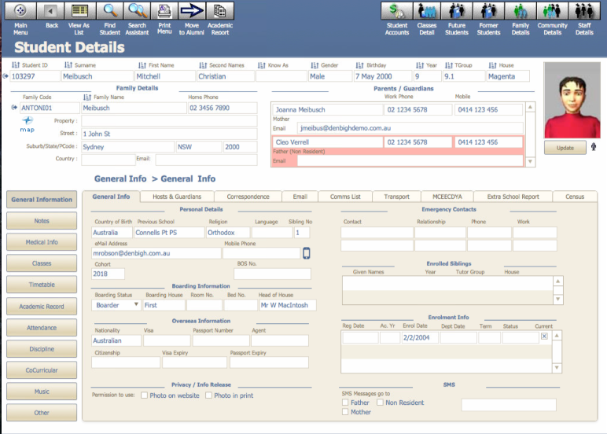
This finds all students in year 9 except 9.2-tutor group.

Find using Operators
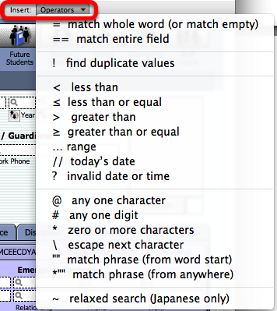
More advanced searches can be run using an Operator. It is a symbol or instruction that allows you to make your find request specific or apply some logic to the find.

Clicking on the operators box to show the menu of operators that can be used in the search criteria. For example to find all students above year 9, you would enter ">9" (greater than 9). To find a range of students from year 9 to 12 enter "9...12".

Find in any Field - Right mouse click
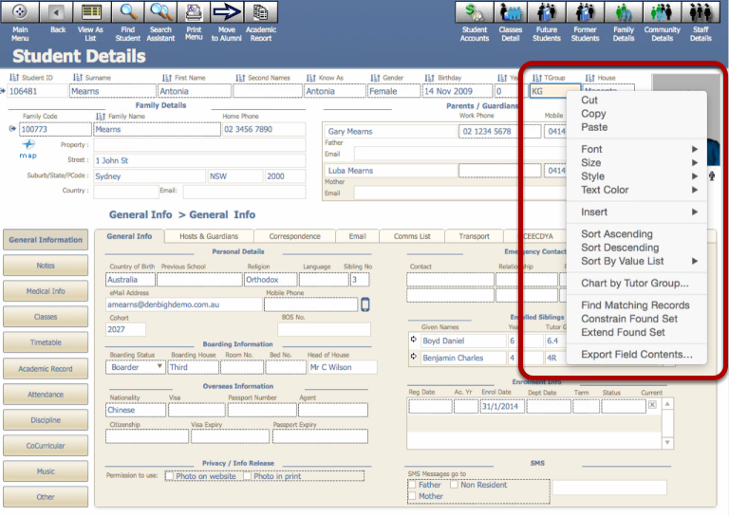
In any field, use the mouse to right click in the field. Choose either Find Matching records, or Constrain Found set to find with in a Find.

Using Shortcuts or function keys
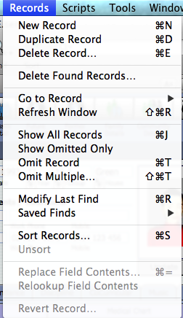
Some of the functions available in the Filemaker menus also have shortcuts usually using the Command (⌘ Apple) key. For example to Show all records hold down the ⌘ key and the letter "J".

Find Student (New Versions of Denbigh 2014)
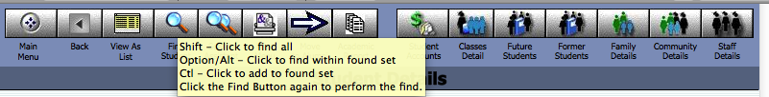
Find all - hold down the shift key and click the Find Student button
Find within in a found set - Hold down the Options/Alt key
Find and add to the found set - Hold down the Control key
Click the Find button or the Continue button to perform the find

Search Assistant
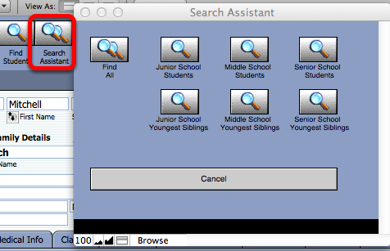
Clicking the Search Assistant button will display a popup menu with a choice of Search functions. (This may vary depending on the school).

Saved and Recent Finds
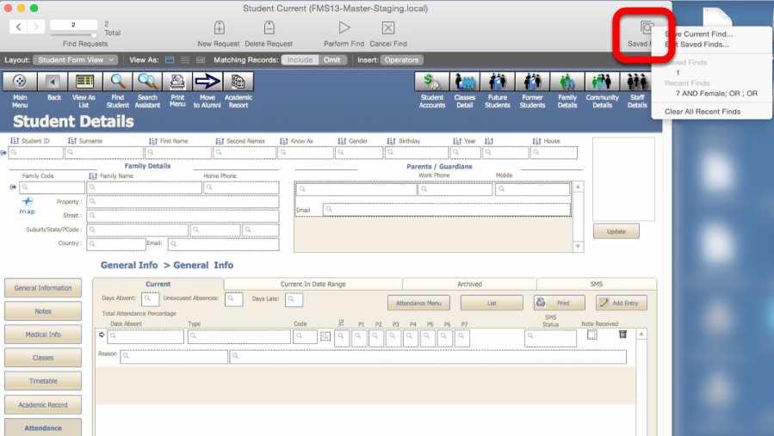
You can see your last several finds in a the Recent Finds list. Also if you have a complex find request that you want to use on a regular basis, you can name it and have it for later use.

Finding random records with Mark Function
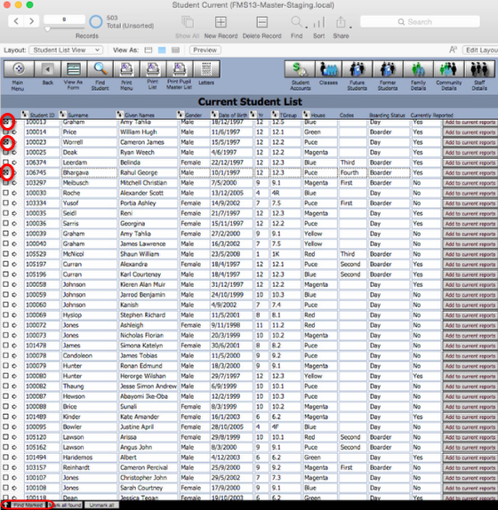
By clicking the checkbox beside a record, then clicking the find marked button will find just those records.

Find Results
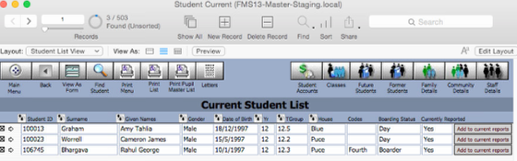
Found just the checked records.

Sort Records
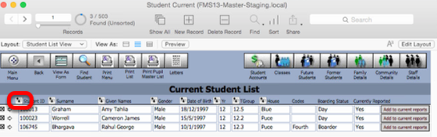
Any fields that have the "sort icon" can be sorted on.
When sorting on numeric fields they are usually lowest to highest and Alpha fields are A - Z (ascending). To sort in descending holding down the Alt key (option key on Windows).

Paste without formatting
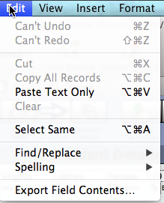
To paste any text without including any formatting, eg Bold, Italics etc.. Press Command Option V on a Mac, or Control Shit V on a Windows computer. Also from the Edit menu, hold down the Option (alt) key and you will get the Past Text Only option. This will paste any copied text without any formatting attached. This function should always be used when copying any text from another program, eg MS Word.

Export Records
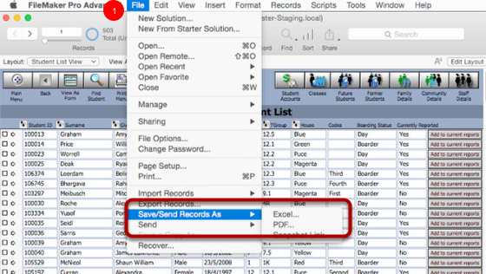
There are quite a few ways to export or save records out of Denbigh. One option is to find the data required and choose the Save/Send Records As - Excel, PDF or a Snapshot Link. Choose excel to export the current data and field names to excel. Save as PDF will create a pdf of the layout. Snapshot link creates a shortcut to this file. (Filemaker developer function)
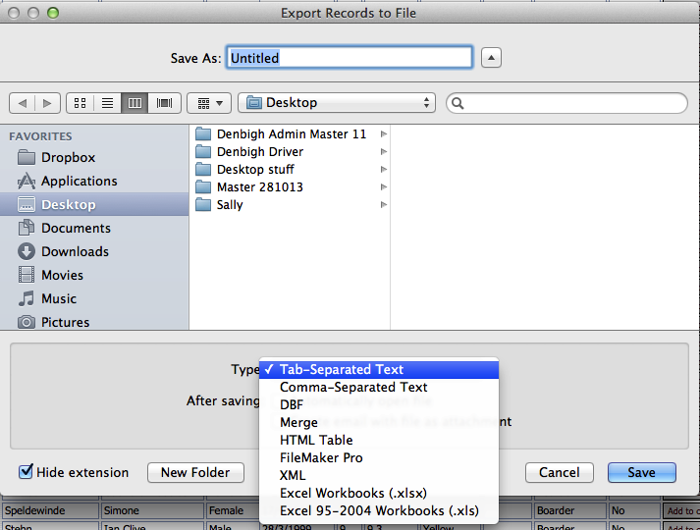
The other option is to choose to export many more fields that may not necessarily be on the current layout. Choose File Menu - Export records. Give the file a name and then choose the file type.

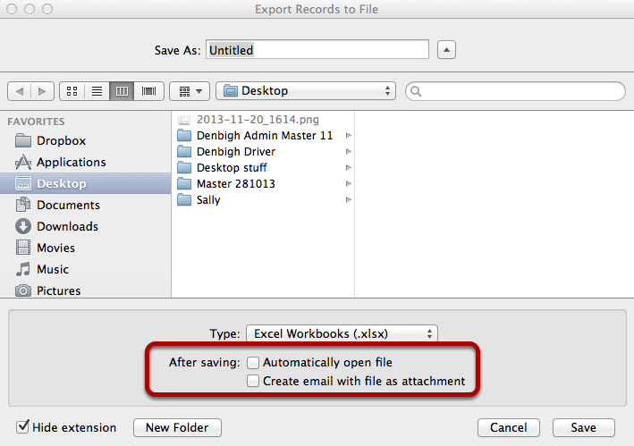
When choosing to export records, check the Automatically open the file or choose to add it to an email as an attachment.

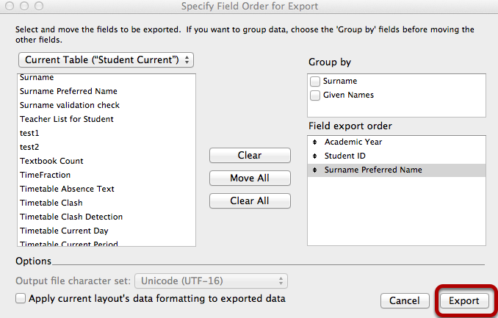
This dialog box allows the user not only to choose the fields but also the files to export data required. Once all fields are chosen, click the Export button.

